PERSONAL INFORMATION: Eszter Jóni
Telephone: 07500908603
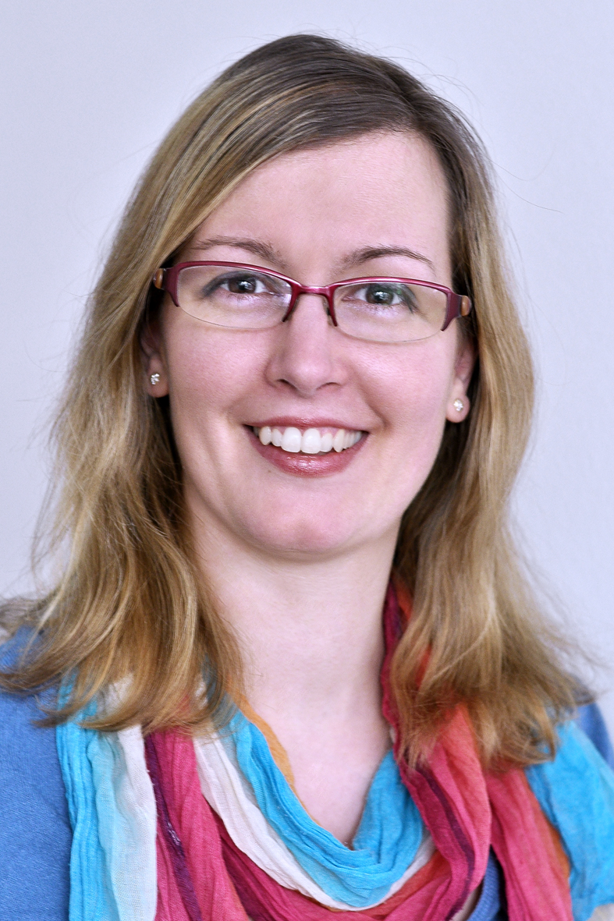
E-mail: jonieszter84@gmail.com

EDUCATION:

2020: I completed a TEFL course and have started to teach English for beginners online

2018: I completed a History teaching practise in Newlands Academy London

2017: SCCD, London: I completed an induction training about the UK education system for oversee teachers

I have the Qualified Teacher Status and a DBS on update service

2010-2014: Eötvös Loránd University, Budapest, Hungary: Doctoral student (PhD) in the field of Russian Studies. I have chosen to specialise in gender studies, specifically the status of women in the former Soviet Union.

2008: Szeged University, Szeged, Hungary: Master’s Degree, History and Russian language; Certificate in European Studies, a special course of six semesters covering the history, security policy, and institutions of the European Union.
2008: Certificate of Medicinal Massage, Szeged, Hungary: This certification qualifies me to work in hospitals, public baths and spas, and health and wellness centres.
2006: Pushkin Institute, Moscow, Russia: I spent one semester studying Russian language, literature and history in Moscow on a state scholarship from the Hungarian government.

CONFERENCES:

2013-2015: I have taken part in conferences in Budapest (ELTE and Andrássy University) in Sopron and in Szabadka, Serbia, where I gave lectures on the condition of women during World War II, laws in connection with women, and social policy toward women in the 1920’s. Specific topics were “The Zhenotdel 1919-1920”, “Soviet Women in World War II”, “Changes in the life of Soviet women during the NEP period”, etc.
2016: This year took a part in BASEES conference (2-4 April 2016, BASEES, Fitzwilliam College /Churchill College, Cambridge): ‘Everyday Life of Soviet Women during World War II’.

WORK EXPERIENCE:
2019-2020 Langtry nursery London: I worked in this nursery as a practitioner.
2019-2017: FRCE Recruitment: I worked as a nursery practitioner. in over 23 different places with this company.
2017:Winlight Recruitment, London: I worked for them as a supplying SEN Teacher assistant in 3 secondary schools.
2015-2016: Champneys Forest Mere Liphook, UK: I worked here in full time as a massage therapist, and did full body, scalp massages, aromatherapy wraps, facials and REIKI treatments.
2014: Vrissaki Beach Hotel, Protaras, Cyprus: I worked as a Massage Therapist.
2014: Vezér Úti Kollégium (VUK), Eötvös Loránd University, Budapest, Hungary: I taught a Russian language course for students in this university dormitory while pursuing my doctoral studies.
2014: Pentachord Training Language School, Budapest, Hungary: I taught Russian language for beginners.
2014: Mammut II Health Center, Budapest, Hungary: I worked as a massage therapist.
2013: Micimackó (“Winnie the Pooh”) Babysitter Company, Budapest, Hungary: I worked as a babysitter caring for children up to the age of 6 years, concentrating on playing, food serving.
2011-2012: OTP Bank, Szeged, Hungary: I worked as a hostess in various local branches of this bank, greeting customers and directing them to the area of the bank appropriate to their visit.
2009-2010: Felsővárosi Óvoda state nursery school, Szeged, Hungary: In this nursery school which specializes in the care and development of children with special educational needs. My primary task was to assist children.
2008: Hotel Forrás, Szeged, Hungary: I completed a practical internship in medicinal massage in the hotel’s physiotherapy and wellness program.

